In vb van word

Sub ProduktievoorschriftWizard()

'MsgBox ("debug")

'("C:\Users\vth\Desktop\msoft.xlsx")

'https://social.msdn.microsoft.com/Forums/en-US/62fceda5-b21a-40b6-857c-ad28f12c1b23/use-excel-vba-to-open-a-text-file-and-search-it-for-a-specific-string?forum=isvvba

Dim strPath As String

strPath = Left(ActiveDocument.Name, 9)

'MsgBox (strPath)

Const strFileName = "C:\Users\VTH\Desktop\template2018\logfiles\msoftdb.txt" ' = via msoft naar excel en dan opslaan als txt

' strSearch = "strPath"

Dim strLine As String

Dim f As Integer

Dim lngLine As Long

Dim blnFound As Boolean

f = FreeFile

Open strFileName For Input As #f

Do While Not EOF(f)

lngLine = lngLine + 1

Line Input #f, strLine

If InStr(1, strLine, strPath, vbTextCompare) > 0 Then

' MsgBox "Search string found in line " & lngLine, vbInformation

' MsgBox (strLine)

'we moeten split doen op tab

Dim WrdArray() As String

'splitsen op tab

WrdArray() = Split(strLine, vbTab)

' Me.TextBox1.Value =WrdArray(0)

' Me.TextBox2.Value = WrdArray(1)

' Me.TextBox3.Value = WrdArray(2)

'Define the variable oVars

Set oVars = ActiveDocument.Variables

'Hide the userform

'Me.Hide

oVars("filenaamzonderextentie").Value = strLine

oVars("artikelnaam").Value = WrdArray(0)

oVars("letref").Value = WrdArray(1) + "-" + WrdArray(2)

'oVars("filenaamzonderextentie").Value = strPath

ActiveDocument.Fields.Update

blnFound = True

Exit Do

End If

Loop

Close #f

If Not blnFound Then

MsgBox "ep , hf en hfpri uit msoft halen ,via excel en in msoftdb.txt zetten", vbInformation

WrdArray(0) = "letomschr. niet gevonden"

Else

MsgBox "alles in msoftdb.txt gevonden + nummers.txt verplabel klaar", vbInformation

End If

'verpakkingslabel genereren in nummers.txt

'printen naar file ?C:\Users\VTH\Desktop\nummers.txt

map = "C:\Users\VTH\Desktop\"

bestand = "nummers.txt"

Dim strFile_Path As String

strFile_Path = map & bestand

Open strFile_Path For Output As #1

'Print #1, "proj" & ActiveSheet.Range("a1").Value

Print #1, WrdArray(1) + "-" + WrdArray(2) & "!kip!" & WrdArray(0)

'file sluiten en vrijgeven

Close #1

'einde 'verpakkingslabel genereren in nummers.txt

'Unload the form

End Sub

Sub UpdateAllFields()

Dim oStory As Range

For Each oStory In ActiveDocument.StoryRanges

oStory.Fields.Update

If oStory.StoryType <> wdMainTextStory Then

While Not (oStory.NextStoryRange Is Nothing)

Set oStory = oStory.NextStoryRange

oStory.Fields.Update

Wend

End If

Next oStory

Set oStory = Nothing

Dim toc As TableOfContents

For Each toc In ActiveDocument.TablesOfContents

toc.Update

Next toc

Set TableOfContents = Nothing

End Sub

Public Sub nummer_ingeven()

Dim str As String

Dim map As String

str = InputBox("Geef het nummer in !")

If Len(str) = 0 Or Len(str) < 13 Then Exit Sub

If Len(str) = 13 Then

map = "L:\letdata\data\" & Mid(str, 4, 2) & "\" & Mid(str, 6, 4) & "\" & Left(str, 1) & "\" & Left(str, 3) & "\"

If Dir(map & str & "\", vbDirectory) <> "" Then map = map & str & "\"

ElseIf Left(str, 2) = "20" And Len(str) = 15 Then

map = "L:\letdata\Customerorders\" & Mid(str, 3, 2) & "\" & Mid(str, 1, 8) & "\" & Mid(str, Len(str) - 5, 2) & "\"

If Dir(map & str & "\", vbDirectory) <> "" Then map = map & str & "\"

ElseIf Left(str, 1) = "0" Or Left(str, 1) = "1" Or Left(str, 1) = "2" Or Left(str, 1) = "3" Then

map = "L:\letdata\data\" & Mid(str, 1, 2) & "\" & Mid(str, 3, 7) & "\" & Mid(str, Len(str) - 5, 2) & "\"

If Dir(map & str & "\", vbDirectory) <> "" Then map = map & str & "\"

Else

For i = 1 To Len(str)

Select Case Mid(str, i, 1)

Case "1", "2", "3", "4", "5", "6", "7", "8", "9"

map = "L:\letdata\Projects\" & Mid(str, i, 2) & "\" & Mid(str, 1, Len(str) - 7) & "\" & Mid(str, Len(str) - 5, 2) & "\"

If Dir(map & str & "\", vbDirectory) <> "" Then map = map & str & "\"

Exit For

Case Else

End Select

Next i

End If

If Dir(map, vbDirectory) = "" Then Exit Sub

Options.DefaultFilePath(Path:=wdPicturesPath) = map

Options.DefaultFilePath(Path:=wdDocumentsPath) = map

End Sub

Sub mstrefurbisch()

'

' macro mst engeland

'

'

sPrompt = "Please serienr , vb : EP180060.001"

sTitle = "Name Entry"

sDefault = "EP"

sUserName = InputBox(sPrompt, sTitle, sDefault)

sVerschil = InputBox("verschil in mm", "geen mm typen enkel getal")

sFilenaamzonderextentie = Left(ActiveDocument.Name, Len(ActiveDocument.Name) - 4)

ActiveDocument.Variables("verschil").Value = sVerschil

ActiveDocument.Variables("letref").Value = sUserName

ActiveDocument.Variables("fileNoext").Value = sFilenaamzonderextentie

ActiveDocument.Variables("calibdatum").Value = Date

ActiveDocument.Variables("geldigtot").Value = DateAdd("yyyy", 1, Date)

ActiveDocument.Fields.Update

''update alle velden ook in koptext en voettext

Dim oStory As Range

For Each oStory In ActiveDocument.StoryRanges

oStory.Fields.Update

If oStory.StoryType <> wdMainTextStory Then

While Not (oStory.NextStoryRange Is Nothing)

Set oStory = oStory.NextStoryRange

oStory.Fields.Update

Wend

End If

Next oStory

Set oStory = Nothing

Dim toc As TableOfContents

For Each toc In ActiveDocument.TablesOfContents

toc.Update

Next toc

Set TableOfContents = Nothing

End Sub

Sub prentjesresizen()

'zet alle prentjes op 2inch van de boord

'prentjes moeten wel property hebben ' achter text'

'want anders is het een inlineshape ipv een shape

Dim i As Long

With ActiveDocument

For i = 1 To .Shapes.Count

With ActiveDocument.Shapes(i)

.RelativeHorizontalPosition = wdRelativeHorizontalPositionPage

.Left = InchesToPoints(1)

End With

Next i

End With

End Sub

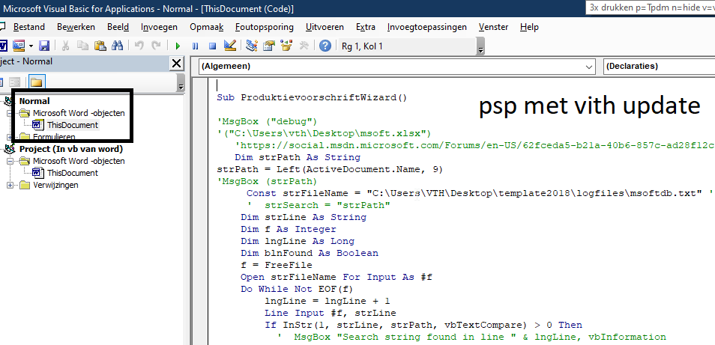

uSERFORM IS NIET MEER IN GEBRUIK , enkel code psp met de vith update , zie 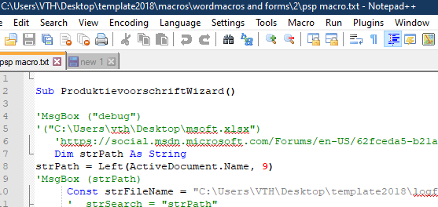

Om de knoppen te hebben in het lint

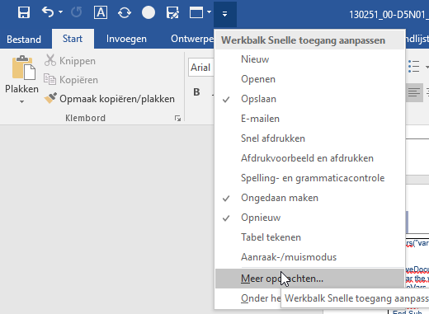

Macros kiezen en je kan ze toevoegen en een icoontje aan toekennen

